**EVIDENCE OF MY ONLINE PRESENCE**

**1.LINKED IN**

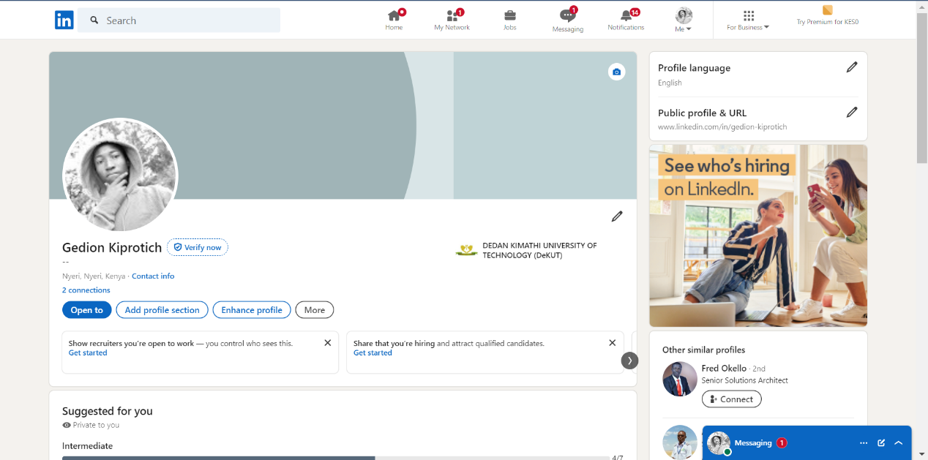 <https://www.linkedin.com/in/gedion-kiprotich/>

**2.WHATSAPP**  
 <https://wa.link/3gihq8>

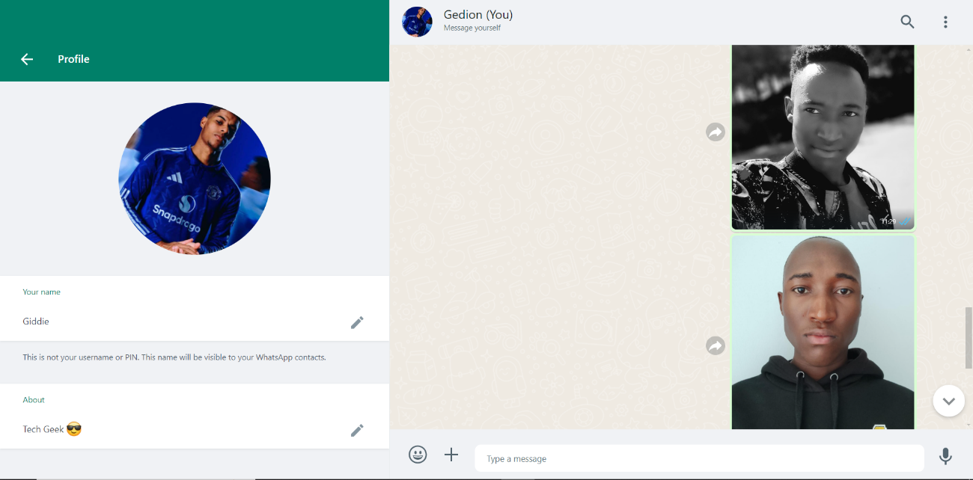

3.**TWITTER**

<https://x.com/@kiprotich_gidii>

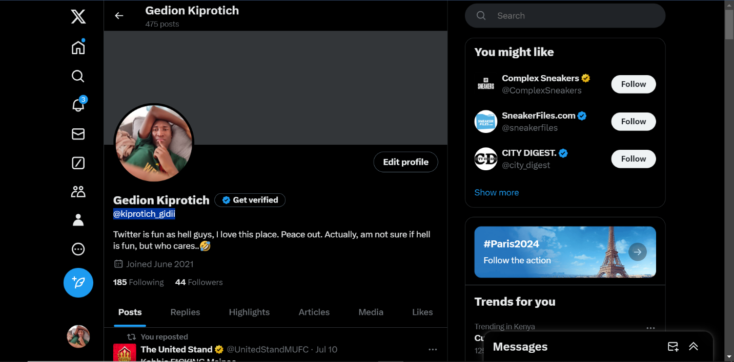

**4.INSTAGRAM**

<https://www.threads.net/@gedion.kiprotich.16?xmt=AQGzs8XK271FNm0Iv36zYcxvK0w0KTeaxAhwFF8aFwjLFdA>

5.FACEBOOK

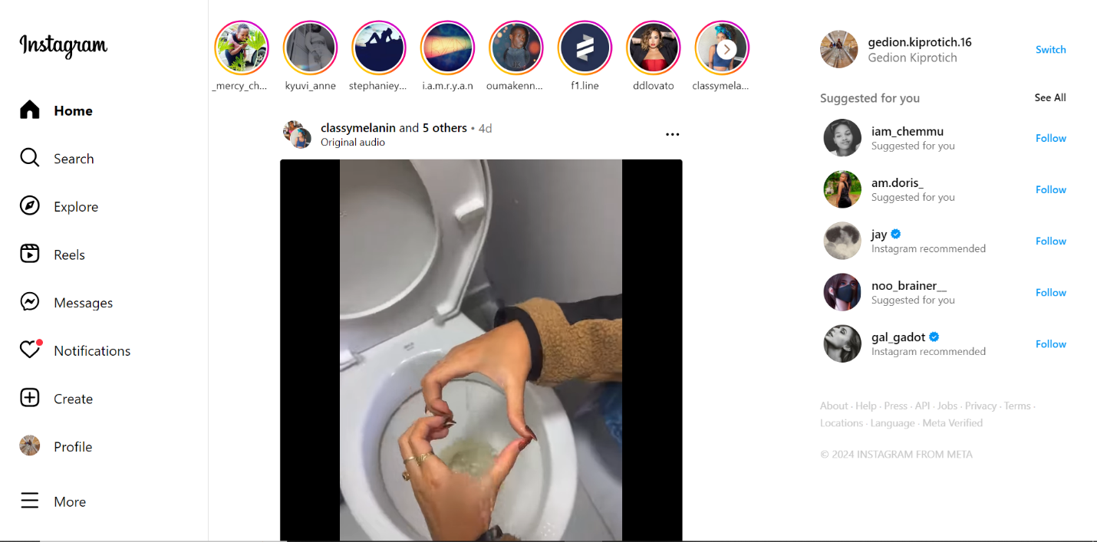

**5.FACEBOOK**

https://www.facebook.com/gedion.kiprotich.16?mibextid=JRoKGi

